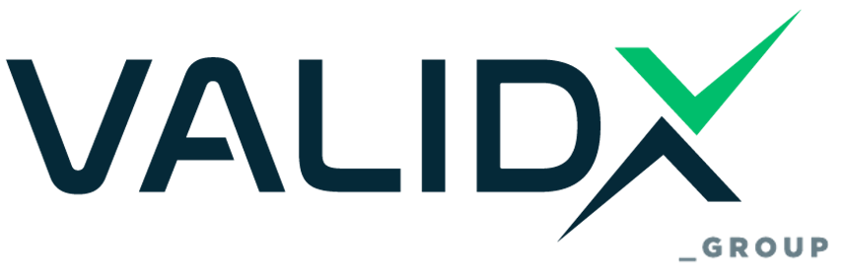

LOGO USAGE REGULATION
(Product Certification – ISO 17065)

VALIDX GROUP grants to the customer exclusively the non-transferable and non-exclusive right to use the certificate and the certification logo and not the right of ownership or in any other way of ownership thereof under any provision, which right of ownership and ownership remains exclusively to and for the benefit of VALIDX GROUP, regardless of whether the Customer has paid a fee for the certification logo and the certificate. The right to use the certificate and the certification logo is granted and revoked at any time in accordance with the general and specific terms of the Organization's System.

The logo can be used in the above format on invoices, accompanying documents, company brochures, advertisements and brochures as well as websites. In the case of cross-certification, all standards and corresponding certificate numbers may be included in the same label.

Also, the logo can appear in a prominent place of the reception and in windows or entrances of shops and exhibitions as there is the possibility of presentation with a certification sticker.

The logo may not be used on a product, nor on its packaging, nor in any other way that may be construed as a sign of conformity of the product. The use of the logo is also prohibited in reports or certificates of laboratory tests, calibrations or controls.

The certificate shall be valid on the date of issue of the certificate and shall be valid for the period indicated therein, provided that the interim annual surveillance inspections are carried out with a positive result for the customer.

The use of the logo and the certificate is made solely by the customer and the certificate, logo or the right to use them may not be transferred, divested, assigned or otherwise and for any other reason made available in whole or in part, with or without remuneration, to any third party, universal, special successor, partner or affiliated Organization, a successor or any other organisational and operational structure or unit, installation or operation without the prior written approval of VALIDX GROUP. If necessary, a re-inspection may be carried out at the premises of the structure or plant to which the license will be transferred, and the certificate and certification logo may be revoked at any time in accordance with the terms of this Regulation.

For more clarifications regarding the use of the logo, please contact the company VALIDX GROUP, telephone 2110011679.

Note to Users

This Regulation applies exclusively to the use of the VALIDX GROUP logo and certification mark in relation to product and process certification activities performed under VALIDX GROUP’s accreditation to ISO/IEC 17065.
For inspection services, SERMI authorizations, and the use of accreditation marks related to ISO/IEC 17020 and ACCREDIA, please refer to VALIDX GROUP Regulation GOR.05 – Use of Logos and Accreditation Marks (Inspection & Authorization – ISO 17020 / ACCREDIA / SERMI).

Amendments
Edition | Chapter | Cause & signs of modification | Drafted by | Approved by | Date
v.2 -> v.3 | Overall | Format Change and Group Structure Information Showcasing the relationship with the new entity VALIDX and the IMS Implementation | Athanasios Arvanitis (Quality Manager) | Angelos Koulouridis  Stergios Zarifidis  Sara Pellegrino | 13/05/2025

